

GROUP ASSIGNMENT

TECHNOLOGY PARK MALAYSIA

**CT042-3-1-IDB**

INTRODUCTION TO DATABASES

HAND OUT DATE: 7th APRIL 2021

HAND IN DATE: 2nd JULY 2021

WEIGHTAGE: 40%

TEAM MEMBERS:

* KEVIN MATTHEW ADYAN (TP058466)
* MARCELL AGUNG WAHYUDI (TP058650)
* SELVAN NICHOLAS (TP058084)
* WATARU SHINZATO (TP061217)

Table of Contents

1.0 DATABASE SCHEMA (STRUCTURE OF DATABASE TABLES / DATA DICTIONARY) 1

1.1 Database Schema 1

1.2Finalised ERD (Entity Relationship Diagram) – Output of the conceptual database design phase 4

1.3Finalised EERD (Enhanced Entity Relationship Diagram) – Output of the logical database design phase 5

1.4 Database diagram generated from the MS SQL Server 2019 8

2.0 SQL-DATA DEFINITION LANGUAGE (DDL) 11

2.1 SQL DDL USED 11

2.1.1 SQL DDL used to create AIRLINE_T 11

2.1.2 SQL DDL used to create BOOKING_OFFICE_T 11

2.1.3 SQL DDL used to create FLIGHT_T 11

2.1.4 SQL DDL used to create PILOT_T 12

2.1.5 SQL DDL used to create FLIGHT_ATTENDANT_T 12

2.1.6 SQL DDL used to create CUSTOMER_T 13

2.1.7 SQL DDL used to create CUST_EMAIL_T 13

2.1.8 SQL DDL used to create CUST_HPHONE_NUMBER_T 13

2.1.9 SQL DDL used to create FLIGHT_BOOKING_T 14

2.1.10 SQL DDL used to create ATTENDANT_SCHEDULE_T 14

2.1.11 SQL DDL used to create PILOT_SCHEDULE_T 15

2.1.12 SQL DDL used to create CUST_BOOKING_PLACE_T 15

2.2 SAMPLES OF DATA USED 16

2.2.1 AIRLINE_T Table 16

2.2.2 BOOKING_OFFICE_T Table 16

2.2.3 FLIGHT_T Table 16

2.2.4 PILOT_T Table 17

2.2.5 FLIGHT_ATTENDANT_T Table 17

2.2.6 CUSTOMER_T Table 17

2.2.7 CUST_EMAIL_T Table 18

2.2.8 CUST_HPHONE_NUMBER_T Table 18

2.2.9 FLIGHT_BOOKING_T Table 19

2.2.10 ATTENDANT_SCHEDULE_T Table 19

2.2.11 PILOT_SCHEDULE_T Table 20

2.2.12 CUST_BOOKING_PLACE_T Table 20

3.0 SQL DML - DATA MANIPULATION LANGUAGE 21

3.1 SQL DML USED 21

3.1.1 SQL DDL commands to insert tuples into AIRLINE_T 21

3.1.2 SQL DML commands to insert tuples into BOOKING_OFFICE_T 21

3.1.3 SQL DML commands to insert tuples into FLIGHT_T 21

3.1.4 SQL DML commands to insert tuples into PILOT_T 22

3.1.5 SQL DML commands to insert tuples into FLIGHT_ATTENDANT_T 23

3.1.6 SQL DML commands to insert tuples into CUSTOMER_T 23

3.1.7 SQL DML commands to insert tuples into CUST_EMAIL_T 24

3.1.8 SQL DML commands to insert tuples into CUST_HPHONE_NUMBER_T 24

3.1.9 SQL DML commands to insert tuples into FLIGHT_BOOKING_T 25

3.1.10 SQL DML commands to insert tuples into ATTENDANT_SCHEDULE_T 25

3.1.11 SQL DML commands to insert tuples into PILOT_SCHEDULE_T 25

3.1.12 SQL DML commands to insert tuples into CUST_BOOKING_PLACE_T 26

3.2 SQL Questions 26

3.2.1 - Question 1 (Marcell Agung W) 26

3.2.2 - Question 2 (Selvan Nicholas) 28

3.2.3- Question 3 (Kevin Matthew Adyan) 31

3.2.4 - Question 4 (Wataru) 35

4.0 CONCLUSION 38

5.0 WORKLOAD MATRIX 39

6.0 REFERENCES 41

# DATABASE SCHEMA (STRUCTURE OF DATABASE TABLES / DATA DICTIONARY)

## Database Schema

Figure 1.1 Database Schema Part 1

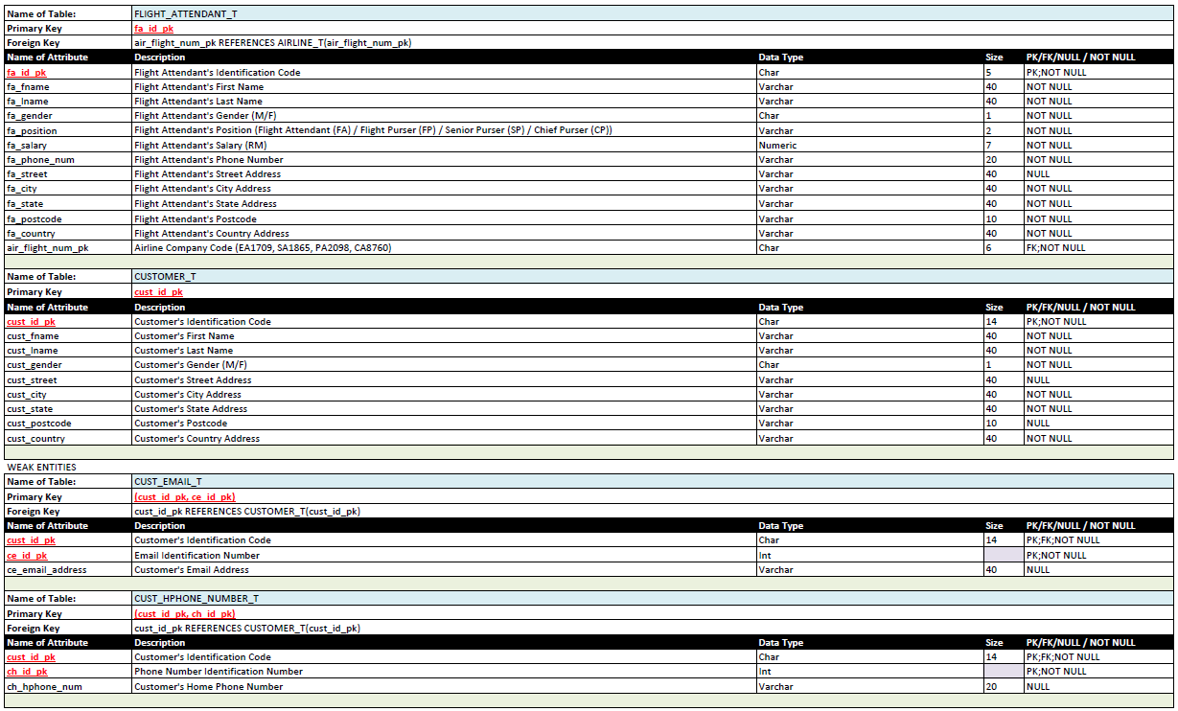

Figure 1.2 Database Schema Part 2

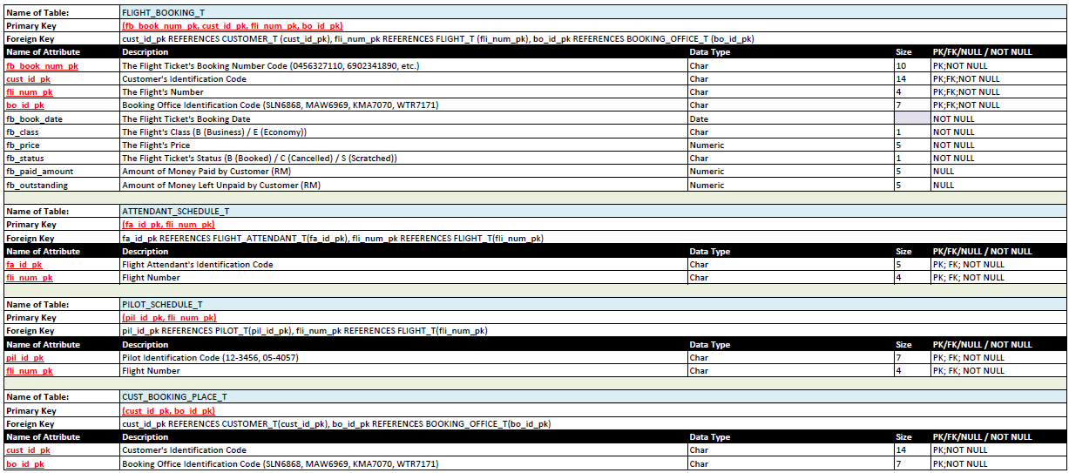

Figure 1.3 Database Schema Part 3

## 1.2Finalised ERD (Entity Relationship Diagram) – Output of the conceptual database design phase

Figure 1.4 Finalised ERD

## Diagram Description automatically generated1.3Finalised EERD (Enhanced Entity Relationship Diagram) – Output of the logical database design phase

Figure 1.5 Finalised EERD

Figure 1.6 Enlarged Finalised Enhanced Entity Relationship Diagram Part 1

Figure 1.7 Enlarged Finalised Enhanced Entity Relationship Diagram Part 2

## 1.4 Database diagram generated from the MS SQL Server 2019

Steps to build a database diagram:

Step 1: Go to MS SQL Server 2019.

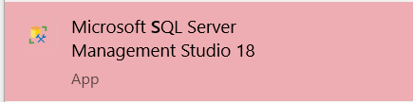

Step 2: Select your database.

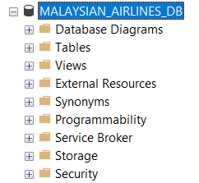

Step 3: Right click on ‘Database Diagrams’.

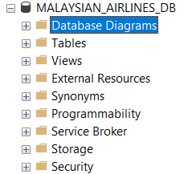

Step 4: Select ‘New Database Diagram’.

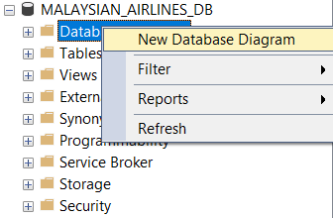

Step 5: Select all the database tables and click ‘Add’.

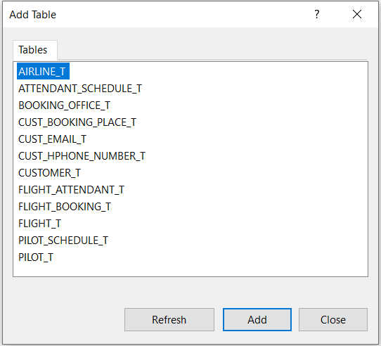

Step 6: Copy a screenshot and attach it below. That is all.

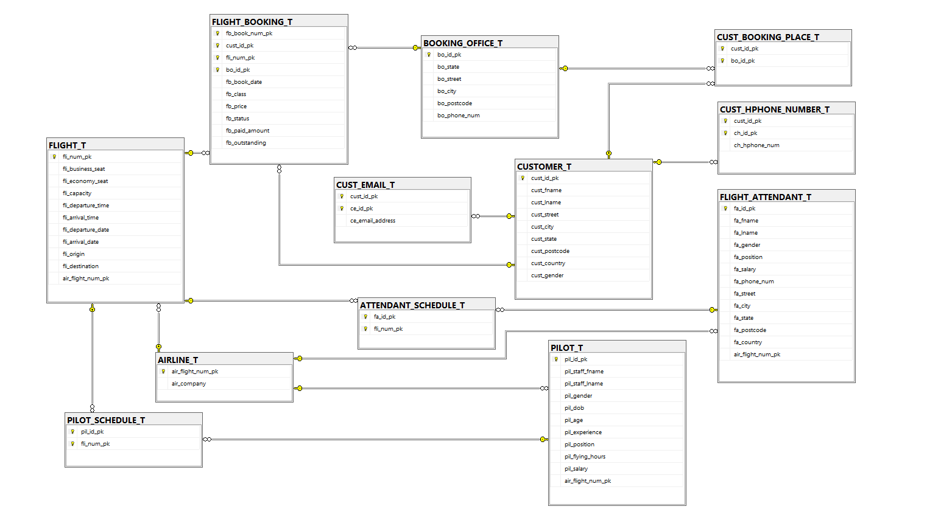

Figure 1.8 Database Diagram

# SQL-DATA DEFINITION LANGUAGE (DDL)

## 2.1 SQL DDL USED

### 2.1.1 SQL DDL used to create AIRLINE_T

CREATE TABLE AIRLINE_T

(

air_flight_num_pk CHAR(6) NOT NULL,

air_company VARCHAR(40) NOT NULL,

PRIMARY KEY (air_flight_num_pk)

);

Figure 2.1 AIRLINE_T Primary Key

### 2.1.2 SQL DDL used to create BOOKING_OFFICE_T

CREATE TABLE BOOKING_OFFICE_T

(

bo_id_pk CHAR(7) NOT NULL,

bo_state VARCHAR(40) NOT NULL,

bo_street VARCHAR(60) NOT NULL,

bo_city VARCHAR(40) NOT NULL,

bo_postcode VARCHAR(10) NULL,

bo_phone_num VARCHAR(20) NOT NULL,

PRIMARY KEY (bo_id_pk)

);

Figure 2.2 BOOKING_OFFICE_T Primary Key

### 2.1.3 SQL DDL used to create FLIGHT_T

CREATE TABLE FLIGHT_T

(

fli_num_pk CHAR(4) NOT NULL,

fli_business_seat NUMERIC(3) NULL,

fli_economy_seat NUMERIC(3) NOT NULL,

fli_capacity NUMERIC(3) NOT NULL,

fli_departure_time TIME NOT NULL,

fli_arrival_time TIME NOT NULL,

fli_departure_date DATE NOT NULL,

fli_arrival_date DATE NOT NULL,

fli_origin VARCHAR(40) NOT NULL,

fli_destination VARCHAR(40) NOT NULL,

air_flight_num_pk CHAR(6) NOT NULL,

PRIMARY KEY (fli_num_pk),

FOREIGN KEY (air_flight_num_pk) REFERENCES AIRLINE_T(air_flight_num_pk)

);

Figure 2.3 FLIGHT_T Primary Key and Foreign Key

### 2.1.4 SQL DDL used to create PILOT_T

CREATE TABLE PILOT_T

(

pil_id_pk CHAR(7) NOT NULL,

pil_staff_fname VARCHAR(40) NOT NULL,

pil_staff_lname VARCHAR(40) NOT NULL,

pil_gender CHAR(1) NOT NULL,

pil_dob DATE NOT NULL,

pil_age NUMERIC(3) NOT NULL,

pil_experience NUMERIC(2) NOT NULL,

pil_position VARCHAR(2) NOT NULL,

pil_flying_hours NUMERIC(6) NOT NULL,

pil_salary NUMERIC(8) NOT NULL,

air_flight_num_pk CHAR(6) NOT NULL,

PRIMARY KEY (pil_id_pk),

FOREIGN KEY (air_flight_num_pk) REFERENCES AIRLINE_T(air_flight_num_pk)

);

Figure 2.4 PILOT_T Primary Key and Foreign Key

### 2.1.5 SQL DDL used to create FLIGHT_ATTENDANT_T

CREATE TABLE FLIGHT_ATTENDANT_T

(

fa_id_pk CHAR(5) NOT NULL,

fa_fname VARCHAR(40) NOT NULL,

fa_lname VARCHAR(40) NOT NULL,

fa_gender CHAR(1) NOT NULL,

fa_position VARCHAR(2) NOT NULL,

fa_salary NUMERIC(7) NOT NULL,

fa_phone_num VARCHAR(20) NOT NULL,

fa_street VARCHAR(40) NULL,

fa_city VARCHAR(40) NOT NULL,

fa_state VARCHAR(40) NOT NULL,

fa_postcode VARCHAR(10) NOT NULL,

fa_country VARCHAR(40) NOT NULL,

air_flight_num_pk CHAR(6) NOT NULL,

PRIMARY KEY (fa_id_pk),

FOREIGN KEY (air_flight_num_pk) REFERENCES AIRLINE_T(air_flight_num_pk)

);

Figure 2.5 FLIGHT_ATTENDANT_T Primary Key and Foreign Key

### 2.1.6 SQL DDL used to create CUSTOMER_T

CREATE TABLE CUSTOMER_T

(

cust_id_pk CHAR(14) NOT NULL,

cust_fname VARCHAR(40) NOT NULL,

cust_lname VARCHAR(40) NOT NULL,

cust_street VARCHAR(40) NULL,

cust_city VARCHAR(40) NOT NULL,

cust_state VARCHAR(40) NOT NULL,

cust_postcode VARCHAR(10) NULL,

cust_country VARCHAR(40) NOT NULL,

cust_gender CHAR(1) NOT NULL,

PRIMARY KEY (cust_id_pk)

);

Figure 2.6 CUSTOMER_T Primary Key

### 2.1.7 SQL DDL used to create CUST_EMAIL_T

CREATE TABLE CUST_EMAIL_T

(

cust_id_pk CHAR(14) NOT NULL,

ce_id_pk INT NOT NULL,

ce_email_address VARCHAR(40) NOT NULL,

PRIMARY KEY (cust_id_pk, ce_id_pk),

FOREIGN KEY (cust_id_pk) REFERENCES CUSTOMER_T(cust_id_pk)

);

Figure 2.7 CUST_EMAIL_T Primary Key and Foreign Key

### 2.1.8 SQL DDL used to create CUST_HPHONE_NUMBER_T

CREATE TABLE CUST_HPHONE_NUMBER_T

(

cust_id_pk CHAR(14) NOT NULL,

ch_id_pk INT NOT NULL,

ch_hphone_num VARCHAR(20) NOT NULL,

PRIMARY KEY (cust_id_pk, ch_id_pk),

FOREIGN KEY (cust_id_pk) REFERENCES CUSTOMER_T(cust_id_pk)

);

Figure 2.8 CUST_HPHONE_NUMBER Primary Key and Foreign Key

### 2.1.9 SQL DDL used to create FLIGHT_BOOKING_T

CREATE TABLE FLIGHT_BOOKING_T

(

fb_book_num_pk CHAR(10) NOT NULL,

cust_id_pk CHAR(14) NOT NULL,

fli_num_pk CHAR(4) NOT NULL,

bo_id_pk CHAR(7) NOT NULL,

fb_book_date DATE NOT NULL,

fb_class CHAR(1) NOT NULL,

fb_price NUMERIC(5) NOT NULL,

fb_status CHAR(1) NOT NULL,

fb_paid_amount NUMERIC(5) NULL,

fb_outstanding NUMERIC(5) NULL,

PRIMARY KEY (fb_book_num_pk, cust_id_pk, fli_num_pk, bo_id_pk),

FOREIGN KEY (cust_id_pk) REFERENCES CUSTOMER_T(cust_id_pk),

FOREIGN KEY (fli_num_pk) REFERENCES FLIGHT_T(fli_num_pk),

FOREIGN KEY (bo_id_pk) REFERENCES BOOKING_OFFICE_T(bo_id_pk)

);

Figure 2.9 FLIGHT_BOOKING_T Primary Key and Foreign Keys

### 2.1.10 SQL DDL used to create ATTENDANT_SCHEDULE_T

CREATE TABLE ATTENDANT_SCHEDULE_T

(

fa_id_pk CHAR(5) NOT NULL,

fli_num_pk CHAR(4) NOT NULL,

PRIMARY KEY (fa_id_pk, fli_num_pk),

FOREIGN KEY (fa_id_pk) REFERENCES FLIGHT_ATTENDANT_T (fa_id_pk),

FOREIGN KEY (fli_num_pk) REFERENCES FLIGHT_T (fli_num_pk)

);

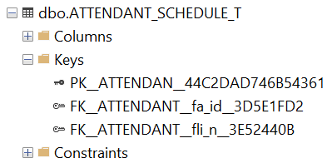

Figure 2.10 ATTENDANT_SCHEDULE_T Primary Key and Foreign Keys

### 2.1.11 SQL DDL used to create PILOT_SCHEDULE_T

CREATE TABLE PILOT_SCHEDULE_T

(

pil_id_pk CHAR(7) NOT NULL,

fli_num_pk CHAR(4) NOT NULL,

PRIMARY KEY (pil_id_pk, fli_num_pk),

FOREIGN KEY (pil_id_pk) REFERENCES PILOT_T (pil_id_pk),

FOREIGN KEY (fli_num_pk) REFERENCES FLIGHT_T (fli_num_pk)

);

Figure 2.11 PILOT_SCHEDULE_T Primary Key and Foreign Keys

### 2.1.12 SQL DDL used to create CUST_BOOKING_PLACE_T

CREATE TABLE CUST_BOOKING_PLACE_T

(

cust_id_pk CHAR(14) NOT NULL,

bo_id_pk CHAR(7) NOT NULL,

PRIMARY KEY (cust_id_pk, bo_id_pk),

FOREIGN KEY (cust_id_pk) REFERENCES CUSTOMER_T(cust_id_pk),

FOREIGN KEY (bo_id_pk) REFERENCES BOOKING_OFFICE_T(bo_id_pk)

);

Figure 2.12 CUST_BOOKING_PLACE_T Primary Key and Foreign Keys

## 2.2 SAMPLES OF DATA USED

### 2.2.1 AIRLINE_T Table

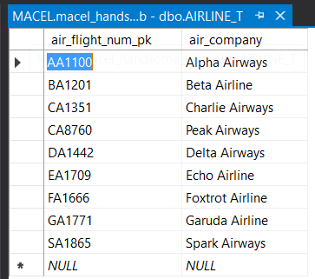

### 2.2.2 BOOKING_OFFICE_T Table

### 2.2.3 FLIGHT_T Table

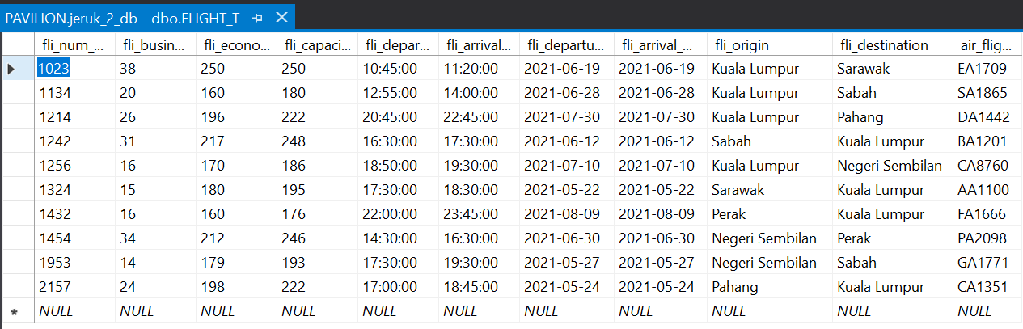

### 2.2.4 PILOT_T Table

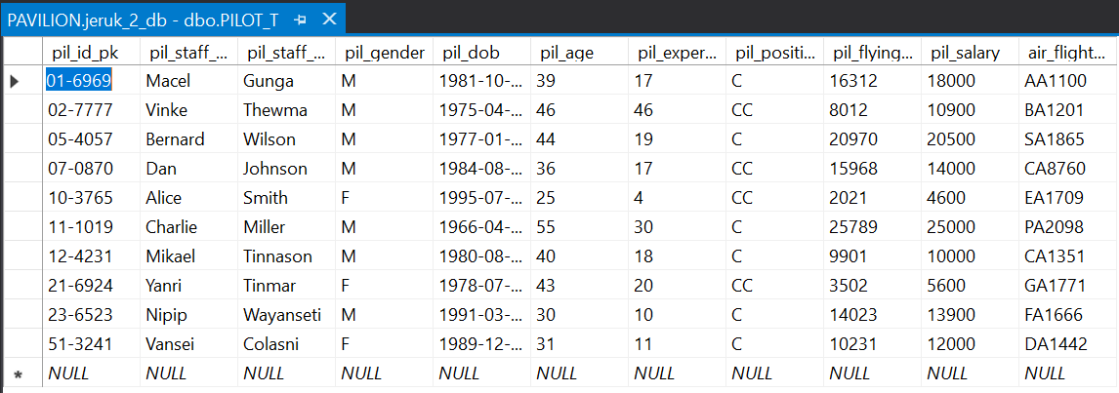

### 2.2.5 FLIGHT_ATTENDANT_T Table

### 2.2.6 CUSTOMER_T Table

### 2.2.7 CUST_EMAIL_T Table

### 2.2.8 CUST_HPHONE_NUMBER_T Table

### 2.2.9 FLIGHT_BOOKING_T Table

### 2.2.10 ATTENDANT_SCHEDULE_T Table

### 2.2.11 PILOT_SCHEDULE_T Table

### 2.2.12 CUST_BOOKING_PLACE_T Table

# SQL DML - DATA MANIPULATION LANGUAGE

## 3.1 SQL DML USED

### 3.1.1 SQL DDL commands to insert tuples into AIRLINE_T

INSERT INTO AIRLINE_T

(

air_flight_num_pk,

air_company)

VALUES　('AA1100','Alpha Airways'),

('BA1201','Beta Airline'),

('CA1351','Charlie Airways'),

('CA8760','Core Airways'),

('PA2098','Peak Airways'),

('DA1442','Delta Airways'),

('EA1709','Echo Airline'),

('FA1666','Foxtrot Airline'),

('GA1771','Garuda Airline'),

('SA1865','Spark Airline');

### 3.1.2 SQL DML commands to insert tuples into BOOKING_OFFICE_T

INSERT INTO BOOKING_OFFICE_T

(

bo_id_pk,

bo_state,

bo_street,

bo_city,

bo_postcode,

bo_phone_num)

VALUES ('KDH6969','Kedah','14, Lorong Air Masin','Kuala Kedah','35000','08461345144'),

('KLT0590','Kelantan','69, Jalan Dusun Raja','Kota Bhuru','46000','08124657981'),

('NSN6969','Negeri Sembilan','8, Millennia Business Centre Jin Tan Sri Manickavasagam','Seremban','70200','0626989333'),

('PHG7070','Pahang','B230,1St Floor Jīn Air Putih','Kuantan','25300','052681214'),

('PKL7373','Wilayah Perseku','12, Lorong Medan Tuanku Satu','Kuala Lumpur','50300','0362033984'),

('PNG1340','Pulau Pinang','11, Lbh Muntri','Georgetown','10200','082111110808'),

('PRK6868','Perak','143, Leboh Perajurit 3 Garden East','Ipoh','31400','0556375098'),

('SBH7171','Sabah','1, Wisma New Far East Taman Far East','Kota Kinabalu','88300','052822931149'),

('SRW7272','Sarawak','1,Jalan Padungan Utara','Kuching','93100','0622247778'),

('TRG3210','Terengganu','14, Jalan Sultan Ismail','Kuala Terengganu','14500','08216549211');

### 3.1.3 SQL DML commands to insert tuples into FLIGHT_T

INSERT INTO FLIGHT_T

(

fli_num_pk,

fli_business_seat,

fli_economy_seat,

fli_capacity,

fli_departure_time,

fli_arrival_time,

fli_departure_date,

fli_arrival_date,

fli_origin,

fli_destination,

air_flight_num_pk)

VALUES ('1023',38,250,250,'10:45:00','11:20:00','2021-06-19','2021-06-19','Kuala Lumpur','Sarawak','EA1709'),

('1134',20,160,180,'12:55:00','14:00:00','2021-06-28','2021-06-28','Kuala Lumpur','Sabah','SA1865'),

('1214',26,196,222,'20:45:00','22:45:00','2021-07-30','2021-07-30','Kuala Lumpur','Pahang','DA1442'),

('1242',31,217,248,'16:30:00','17:30:00','2021-06-12','2021-06-12','Sabah','Kuala Lumpur','BA1201'),

('1256',16,170,186,'18:50:00','19:30:00','2021-07-10','2021-07-10','Kuala Lumpur','Negeri Sembilan','CA8760'),

('1324',15,180,195,'17:30:00','18:30:00','2021-05-22','2021-05-22','Sarawak','Kuala Lumpur','AA1100'),

('1432',16,160,176,'22:00:00','23:45:00','2021-08-09','2021-08-09','Perak','Kuala Lumpur','FA1666'),

('1454',34,212,246,'14:30:00','16:30:00','2021-06-30','2021-06-30','Negeri Sembilan','Perak','PA2098'),

('1953',14,179,193,'17:30:00','19:30:00','2021-05-27','2021-05-27','Negeri Sembilan','Sabah','GA1771'),

('2157',24,198,222,'17:00:00','18:45:00','2021-05-24','2021-05-24','Pahang','Kuala Lumpur','CA1351');

### 3.1.4 SQL DML commands to insert tuples into PILOT_T

INSERT INTO PILOT_T

(

pil_id_pk,

pil_staff_fname,

pil_staff_lname,

pil_gender,

pil_dob,

pil_age,

pil_experience,

pil_position,

pil_flying_hours,

pil_salary,

air_flight_num_pk)

VALUES ('01-6969','Macel','Gunga','M','1981-10-13',39,17,'C',16312,18000,'AA1100'),

('02-7777','Vinke','Thewma','M','1975-04-02',46,46,'CC',8012,10900,'BA1201'),

('05-4057','Bernard','Wilson','M','1977-01-01',44,19,'C',20970,20500,'SA1865'),

('07-0870','Dan','Johnson','M','1984-08-05',36,17,'CC',15968,14000,'CA8760'),

('10-3765','Alice','Smith','F','1995-07-27',25,4,'CC',2021,4600,'EA1709'),

('11-1019','Charlie','Miller','M','1966-04-08',55,30,'C',25789,25000,'PA2098'),

('12-4231','Mikael','Tinnason','M','1980-08-17',40,18,'C',9901,10000,'CA1351'),

('21-6924','Yanri','Tinmar','F','1978-07-30',43,20,'CC',3502,5600,'GA1771'),

('23-6523','Nipip','Wayanseti','M','1991-03-22',30,10,'C',14023,13900,'FA1666'),

('51-3241','Vansei','Colasni','F','1989-12-13',31,11,'C',10231,12000,'DA1442');

### 3.1.5 SQL DML commands to insert tuples into FLIGHT_ATTENDANT_T

INSERT INTO FLIGHT_ATTENDANT_T

(

fa_id_pk,

fa_fname,

fa_lname,

fa_gender,

fa_position,

fa_salary,

fa_phone_num,

fa_street,

fa_city,

fa_state,

fa_postcode,

fa_country,

air_flight_num_pk)

VALUES ('0-564','Ann','Ross','F','CP',8000,'6026933777','Jalan Tanjung Chat 4','Kota Bharu','Kelantan','15400','Malaysia','SA1865'),

('0-565','John','Taylor','M','FP',3500,'6521245618','678A Jurong West Street 64','Singapore','Singapore','641678','Singapore','CA8760'),

('1-235','Catherine','Smith','F','FA',2800,'6024154233','Jalan Teknologi 5','Kuala Lumpur','Wilayah Persekutuan Kuala Lumpur','57000','Malaysia','EA1709'),

('1-333','Mike','Hunt','M','FA',3000,'6223897534','Jalan Benteng Jaya 16','Kota Tangerang','Banten','15111','Indonesia','PA2098'),

('2-252','Rihen','Kelmai','M','FA',3200,'62965748351','Jalan Soekarno Hatta 61','Kota Balikpapan','East Kalimantan','76214','Indonesia','DA1442'),

('4-562','Kelmic','Kom','M','SP',6900,'6598217168','Jalan Setiabudhi 8','Kota Bandung','Jawa Barat','40141','Indonesia','BA1201'),

('6-693','Terpe','Yenbri','M','FP',5000,'65789451345','Jalan Bung Tomo 4','Kota Surabaya','East Java','60245','Indonesia','FA1666'),

('6-969','Ranzah','Nihaf','F','FA',2800,'62212691611','Jalan Shonda Makurmpad','Kota Malang','East Java','65113','Indonesia','GA1771'),

('9-325','Vinke','Wansei','F','CP',8100,'6519452014','Jalan Dermaga 69','Kota Samarinda','East Kalimantan','75242','Indonesia','AA1100'),

('9-936','Nathanyo','Cenvi','F','FA',3000,'62821450142','Grusiva Niyamasubar St','City of Seria','Belait','2733','Brunei','CA1351');

### 3.1.6 SQL DML commands to insert tuples into CUSTOMER_T

INSERT INTO CUSTOMER_T

(

cust_id_pk,

cust_fname,

cust_lname,

cust_street,

cust_city,

cust_state,

cust_postcode,

cust_country,

cust_gender)

VALUES ('123400-56-9876','Ching','Chong','Jiu Wei Cun 81 Hao','Sha Tian','Guang Dong','523000','China','F'),

('164973-59-1576','Usman','Mailis','No.10 Kampung','Bota','Perak','32600','Malaysia','M'),

('550106-12-5821','Dig','Beck','Seksyen Bb 11, Bukit Beruntung','Rawang','Selangor','48300','Malaysia','M'),

('581235-61-2456','Dhason','Padnakunar','Lot 3706 Jin Tengah','Bandar Seri Begawan','Brunei and Muara','8411','Brunei','M'),

('610522-10-5378','Ligma','Bllas','No.12 Jalan Bersatu (13/4)','Petaling Jaya','Selangor','46200','Brunei','F'),

('615493-59-7984','Sivaguru','Kael','No.3 Jln Sek Keb','Bukit Payong','Terengganu','21400','Malaysia','M'),

('923497-36-5951','Tanvir','Subarnamiyn','20-1 A Jln Pjs 3/36 Taman Sri Manja','Petaling Jaya','Selangor','58200','Malaysia','M'),

('930906-14-7043','Ben','Dover','No.8 Jin Air Panas','Kuala Lumpur','Wilayah Persekutuan Kuala Lumpur','53200','Malaysia','M'),

('941130-07-5153','Icewallow','Kam','Jalan Setiabudi 10','Malang','Jawa Timur','65111','Indonesia','F'),

('985632-41-6932','Chad','Upin','66A Jln Tabuan','Kuching','Sarawak','93100','Malaysia','M'),

('691234-43-7872','Ahmad','Qafi','13 Jalan Payah, Kampung Aik Hwa,','Muar','Johor','84200','Malaysia','M'),

('771203-90-9922','Rosa','Fatima', '13 Jalan Payah, Kampung Aik Hwa,','Muar','Johor','84200','Malaysia','F');

### 3.1.7 SQL DML commands to insert tuples into CUST_EMAIL_T

INSERT INTO CUST_EMAIL_T

(

cust_id_pk,

ce_id_pk,

ce_email_address)

VALUES ('550106-12-5821',1,'digbeck@hotmail.com'),

('930906-14-7043',2,'bendover69@yahoo.com'),

('941130-07-5153',3,'wallowicekam123@gmail.com'),

('610522-10-5378',4,'ligmaballs@hotmail.com'),

('123400-56-9876',5,'chingchongchang@yahoo.com'),

('581235-61-2456',6,'dhason@apu.edu.my'),

('615493-59-7984',7,'tanvir@apu.edu.my'),

('923497-36-5951',8,'sivaguru123@yahoo.com'),

('164973-59-1576',9,'usmanthegreat@yahoo.com'),

('985632-41-6932',10,'xXDemoLordXx@yahoo.com')

### 3.1.8 SQL DML commands to insert tuples into CUST_HPHONE_NUMBER_T

INSERT INTO CUST_HPHONE_NUMBER_T

(

cust_id_pk,

ch_id_pk,

ch_hphone_num)

VALUES ('550106-12-5821',1,'6084901516'),

('930906-14-7043',2,'60249241562'),

('941130-07-5153',3,'62498456852'),

('610522-10-5378',4,'67180200120'),

('123400-56-9876',5,'8156562001'),

('581235-61-2456',6,'67199998877'),

('615493-59-7984',7,'60164624389'),

('923497-36-5951',8,'608214944201'),

('164973-59-1576',9,'60121249895'),

('985632-41-6932',10,'60333321644');

### 3.1.9 SQL DML commands to insert tuples into FLIGHT_BOOKING_T

INSERT INTO FLIGHT_BOOKING_T

(

fb_book_num_pk,

fli_num_pk,

cust_id_pk,

bo_id_pk,

fb_book_date,

fb_class,

fb_price,

fb_status,

fb_paid_amount,

fb_outstanding)

VALUES ('0456327110','1023','550106-12-5821','PKL7373','2021-04-17','B',600,'S',100,400),

('6902341890','1134','930906-14-7043','PKL7373','2020-08-09','E',220,'B',200,20),

('9736440028','1454','941130-07-5153','NSN6969','2020-08-16','E',230,'C', NULL, NULL),

('8969912362','1256','610522-10-5378','PKL7373','2020-12-21','E',170,'B',170, NULL),

('6124953478','1324','123400-56-9876','SBH7171','2020-12-14','B',1000,'B',900,100),

('8453125549','1242','581235-61-2456','SRW7272','2021-02-06','B',575,'B',550,25),

('1324875613','1432','615493-59-7984','PHG7070','2021-01-09','E',235,'C', NULL, NULL),

('4950351204','2157','923497-36-5951','PKL7373','2021-04-12','E',220,'S', NULL, NULL),

('0326592175','1953','164973-59-1576','PRK6868','2020-10-13','E',215,'S', NULL, NULL),

('1203562047','1214','985632-41-6932','NSN6969','2020-12-19','B',240,'C', NULL, NULL);

### 3.1.10 SQL DML commands to insert tuples into ATTENDANT_SCHEDULE_T

INSERT INTO ATTENDANT_SCHEDULE_T

(

fa_id_pk,

fli_num_pk)

VALUES ('1-235','1023'),

('0-564','1134'),

('1-333','1454'),

('0-564','1256'),

('9-325','1324'),

('4-562','1242'),

('9-936','2157'),

('2-252','1214'),

('6-693','1432'),

('6-969','1953');

### 3.1.11 SQL DML commands to insert tuples into PILOT_SCHEDULE_T

INSERT INTO PILOT_SCHEDULE_T

(

pil_id_pk,

fli_num_pk)

VALUES ('10-3765','1023'),

('05-4057','1134'),

('11-1019','1454'),

('07-0870','1256'),

('01-6969','1324'),

('02-7777','1242'),

('12-4231','2157'),

('51-3241','1214'),

('23-6523','1432'),

('21-6924','1953');

### 3.1.12 SQL DML commands to insert tuples into CUST_BOOKING_PLACE_T

INSERT INTO CUST_BOOKING_PLACE_T

(

cust_id_pk,

bo_id_pk)

VALUES ('550106-12-5821','PKL7373'),

('930906-14-7043','PKL7373'),

('941130-07-5153','NSN6969'),

('610522-10-5378','PKL7373'),

('123400-56-9876','SBH7171'),

('581235-61-2456','SRW7272'),

('615493-59-7984','PHG7070'),

('923497-36-5951','PKL7373'),

('164973-59-1576','PRK6868'),

('985632-41-6932','NSN6969');

## 3.2 SQL Questions

### 3.2.1 - Question 1 (Marcell Agung W)

1. Display all customers whose first name ends with consonant ‘*d*’ and lives in *Sarawak.*

**SQL DML CODE**

SELECT c.cust_fname AS 'Customer First Name',

c.cust_lname AS 'Customer Last Name'

FROM CUSTOMER_T c

WHERE ( c.cust_fname LIKE '%d' ) AND

( c.cust_state LIKE 'Sarawak' )

**SQL SERVER RESULT**

Figure 3.1 Question 1 Student 1 SQL Server Result

1. Display the average of salary for pilots who have reached or exceeded *20,000* flying hours.

**SQL DML CODE**

SELECT AVG(p.pil_salary) AS 'Average Pilot Salary'

FROM PILOT_T p

WHERE ( p.pil_flying_hours >= 20000 )

**SQL SERVER RESULT**

Figure 3.2 Question 2 Student 1 SQL Server Result

1. List the first name, last name, age, and experience of pilots who have piloted the flight for *Spark Airways.*

**SQL DML CODE**

SELECT p.pil_staff_fname AS 'Pilot First Name',

p.pil_staff_lname AS 'Pilot Last Name',

p.pil_age AS 'Pilot Age',

p.pil_experience AS 'Pilot Experience'

FROM PILOT_T p, AIRLINE_T a

WHERE ( p.air_flight_num_pk = a.air_flight_num_pk ) AND

( a.air_company LIKE 'Spark Airways' )

**

Figure 3.3 Question 3 Student 1 SQL Server Result

### 3.2.2 - Question 2 (Selvan Nicholas)

1. Display customer’s first name and last name who have made bookings.

**SQL DML CODE**

SELECT c.cust_fname AS 'CUSTOMER FIRST NAME',

c.cust_lname AS 'CUSTOMER LAST NAME'

FROM CUSTOMER_T c, CUST_BOOKING_PLACE_T bp

WHERE ( ( c.cust_id_pk = bp.cust_id_pk ) )

**SQL SERVER RESULT**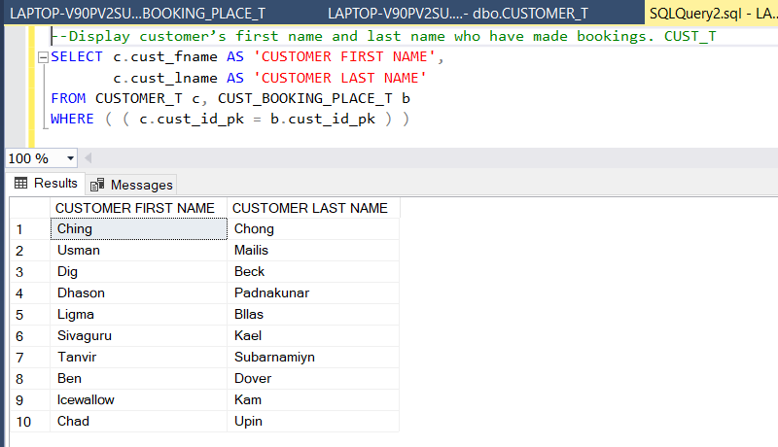

Figure 3.4 Question 1 Student 2 SQL Server Result

1. List flight attendant’s full name and position who have worked in the same flight as a pilot named ‘*Mikael Tinnason*’.

**SQL DML CODE**

SELECT fa.fa_fname AS 'FLIGHT ATTENDANT FIRST NAME',

fa.fa_lname AS 'FLIGHT ATTENDANT LAST NAME',

fa.fa_position AS 'FLIGHT ATTENDANT POSITION'

FROM FLIGHT_ATTENDANT_T fa, ATTENDANT_SCHEDULE_T att

WHERE ( (fa.fa_id_pk = att.fa_id_pk) AND

att.fli_num_pk =

( SELECT ps.fli_num_pk AS 'PILOT FLIGHT NUMBER'

FROM PILOT_T p, PILOT_SCHEDULE_T ps

WHERE ( ( ps.pil_id_pk = p.pil_id_pk ) AND

( p.pil_staff_fname = 'Mikael' AND

( p.pil_staff_lname = 'Tinnason' ) )

)

)

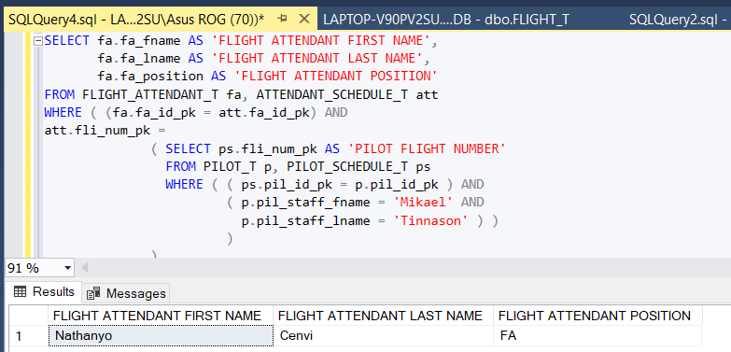

Figure 3.5 Question 2 Student 2 SQL Server Result

**SQL SERVER RESULT**

1. List all customers who did not live in any of the airline offices located. Please display the customer first name, last name, and customer’s state.

**SQL DML CODE**

SELECT c.cust_fname AS 'CUSTOMER FIRST NAME',

c.cust_lname AS 'CUSTOMER LAST NAME',

c.cust_state AS 'CUSTOMER STATE'

FROM CUSTOMER_T c

WHERE (

c.cust_state NOT IN ( SELECT bo_state AS 'BOOKING OFFICE STATE'

FROM BOOKING_OFFICE_T bo

)

)

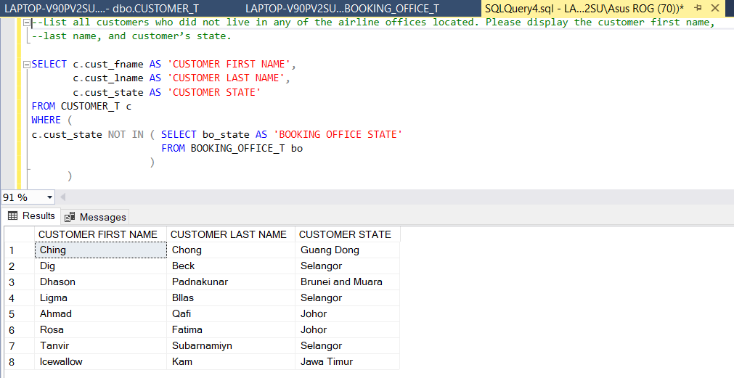

Figure 3.6 Question 3 Student 2 SQL Server Result

**SQL SERVER RESULT**

### 3.2.3- Question 3 (Kevin Matthew Adyan)

1. Display customer’s first name, flight booking number, booking date, flight airlines name, date of departure, time of departure, and status indicator is *Canceled.*

**SQL DML CODE**

SELECT c.cust_fname AS 'Customer First Name',

fb.fb_book_num_pk AS 'Flight Booking Number',

fb.fb_book_date AS 'Flight Booking Date',

a.air_company AS 'Airline Name',

f.fli_departure_date AS 'Departure Date',

f.fli_departure_time AS 'Departure Time',

fb.fb_status AS 'Status'

FROM CUSTOMER_T c, FLIGHT_BOOKING_T fb, AIRLINE_T a, FLIGHT_T f

WHERE ( ( fb.fb_status = 'C' ) AND

( fb.fli_num_pk = f.fli_num_pk ) AND

( fb.cust_id_pk = c.cust_id_pk ) AND

( f.air_flight_num_pk = a.air_flight_num_pk ) )

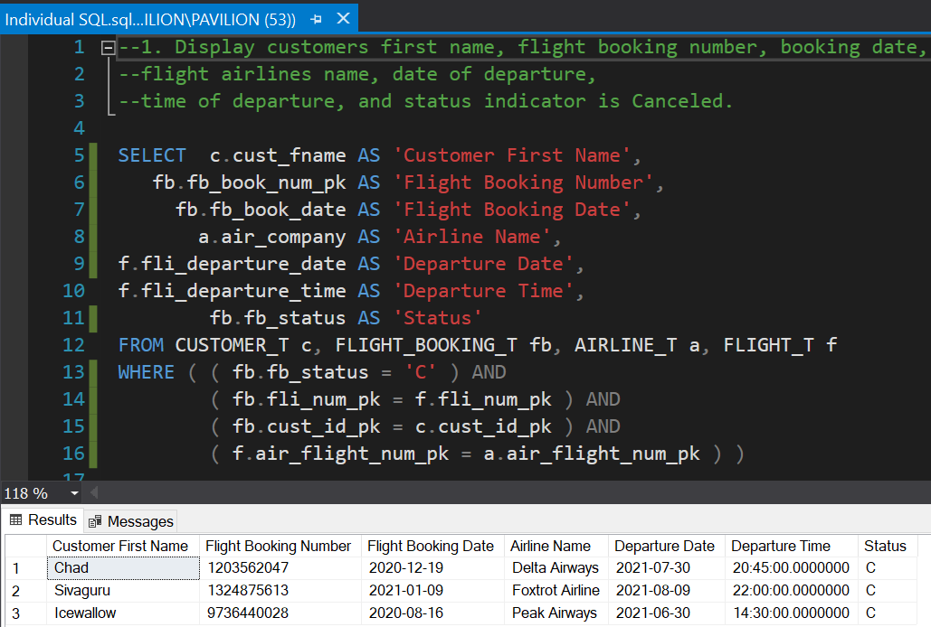**SQL Server Result**

Figure 3.7 Question 1 Student 3 SQL Server Result

1. List all customer’s first name and last name who did not place any booking. Sort the records by customer id in descending order.

**SQL DML CODE**

SELECT c.cust_id_pk AS 'Customer ID',

c.cust_fname AS 'First Name',

c.cust_lname AS 'Last Name'

FROM CUSTOMER_T c

WHERE ( c.cust_id_pk NOT IN ( SELECT fb.cust_id_pk AS 'Customer ID'

FROM FLIGHT_BOOKING_T fb) ) --sub query

ORDER BY c.cust_id_pk DESC

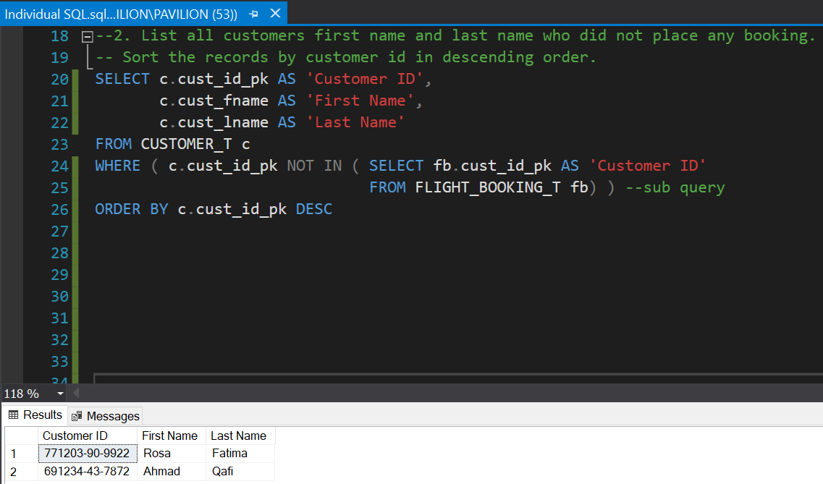**SQL Server Result**

Figure 3.8 Question 2 Student 3 SQL Server Result

1. List all customer’s first name and last name who still have outstanding balance for their flight bookings. Sort the records based on the outstanding balance in ascending order.

**SQL DML CODE**

SELECT c.cust_fname AS 'Customer First Name',

c.cust_lname AS 'Customer Last Name',

fb.fb_outstanding AS 'Outstanding Balance'

FROM CUSTOMER_T c, FLIGHT_BOOKING_T fb

WHERE ( ( c.cust_id_pk = fb.cust_id_pk ) AND

( fb.fb_outstanding IS NOT NULL ) )

ORDER BY fb.fb_outstanding

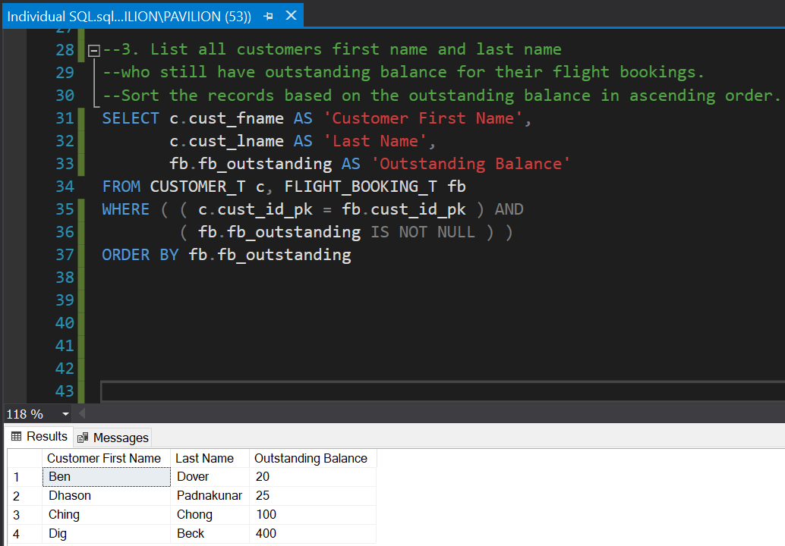**SQL Server Result**

Figure 3.9 Question 3 Student 3 SQL Server Result

### 3.2.4 - Question 4 (Wataru)

1. Find the highest salary of flight attendants.

**SQL DML CODE**

SELECT MAX (fa.fa_salary) AS ‘FLIGHT ATTENDANT HIGHEST SALARY’

FROM FLIGHT_ATTENDANT_T fa

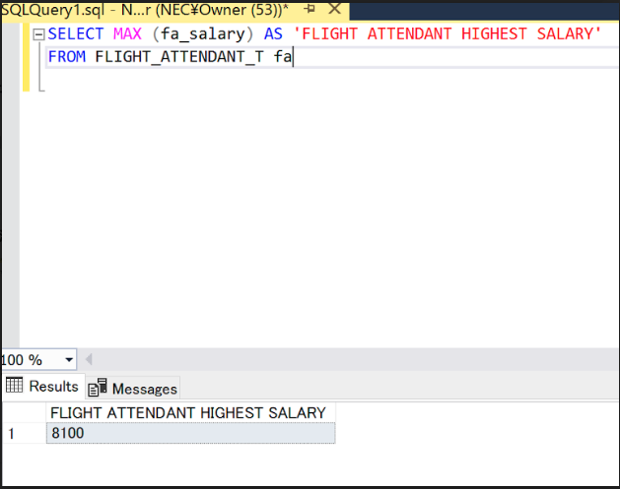 **SQL Server Result**

Figure 3.10 Question 1 Student 4 SQL Server Result

1. List the name and the position of flight attendants whose salary is neither *2,800* nor *3,500*.

**SQL DML CODE**

SELECT fa.fa_fname AS ‘ATTENDANT FIRST NAME’,

fa.fa_lname AS ‘LAST NAME’,

fa.fa_position AS ‘POSITION’,

fa.fa_salary AS ‘SALARY’

FROM FLIGHT_ATTENDANT_T fa

WHERE NOT (fa.fa_salary = 2800 OR fa.fa_salary = 3500)

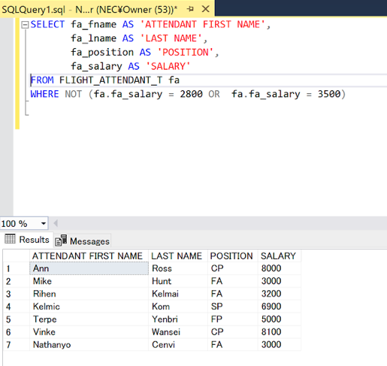 **SQL Server Result**

Figure 3.11 Question 2 Student 4 SQL Server Result

1. List the booking’s date, flight number, and the client’s last name where the client does not have any outstanding balance.

**SQL DML CODE**

SELECT fb.fb_book_date AS ‘BOOKING DATE’,

fb.fli_num_pk AS ‘FLIGHT NUMBER’,

c.cust_lname AS ‘CUSTOMER LAST NAME’

FROM FLIGHT_BOOKING_T fb, CUSTOMER_T c

WHERE ( ( fb.cust_id_pk = c.cust_id_pk ) AND

( fb.fb_outstanding IS NULL ) )

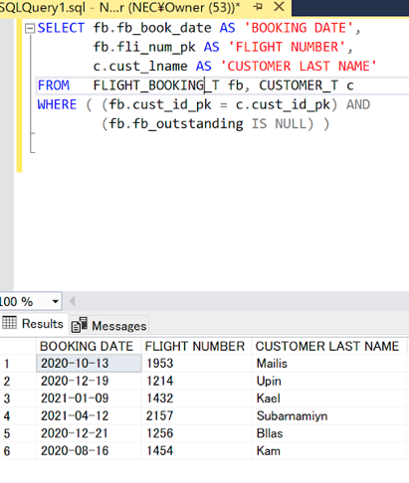 **SQL Server Result**

Figure 3.12 Question 3 Student 4 SQL Server Result

# CONCLUSION

This assignment was a continuation from the part 1 of the IDB assignment. Just like the first part of the assignment documentation that the team has already done, the team also decides to divide the work equally between the team members. This documentation assignment is made possible with the utilisation of Microsoft Word as the compiler media and Microsoft SQL Server Management Studio as the base of the practical SQL codes and databases.

In doing this part 2 IDB assignment, the group leader, Mr. Kevin Matthew and the team members, Mr. Marcell Agung, Mr. Selvan Nicholas and Mr. Wataru Shinzato worked cooperatively and coordinated the process well to eventually produce this assignment documentation. Additionally, the IDB team’s lecturer and advisor, Mr. Dhason Padmakumar, also helped a lot in guiding and assisting the team in producing this documentation. Without the guidance from Mr. Dhason and the cooperation from the team, this assignment would not have been made possible.

Through this assignment, the team’s knowledge of databases has widened even more. The team learned a lot of database knowhow and expertise that will help them achieve a professional industry-world skillset. Learning how to use a Database Management System, inserting data to tables, writing clean SQL codes and mastering how to apply SQL to produce required data results really has made the team become proficient in managing databases.

The skills that are mentioned above was used by the team to put together a clean and detailed database regarding the Malaysian Airlines Reservation as aforementioned in part 1 of the assignment. The database was constructed in the Microsoft SQL Server Management Studio, which is a Database Management System (DBMS) platform that the team are familiar with. The constructed database is complex yet detailed and clear, making the constructed database a crucial aspect in the Malaysian Airlines Reservation System.

Nonetheless, the team members have put in everything they got and have successfully constructed this thorough database. All the team members have done their part in doing the tasks and completed their tasks well. There are no conflicts and misunderstanding in the process of doing this part of the assignment and everything went well. The teamwork between the team members also improved significantly than the first part of the assignment. To summarize, the team felt that doing this assignment is a meaningful experience and will further improve their skillset in creating and managing databases. The results are also satisfactory to the team and the team hoped to apply the vast amount of knowledge gained at the workplace in the future.

# WORKLOAD MATRIX

|  |  |  |  |  |  |
| --- | --- | --- | --- | --- | --- |
|  | | | | | |
|
| **TASK ID** | **TASK NAME** | **DURATION** | **START DATE** | **END DATE** | **MEMBER(S) CONTRIBUTED** |
| 1.0 | **DATABASE SCHEMA (STRUCTURE OF DATABASE TABLES / DATA DICTIONARY)** |  | | | |
|  | 1.1Database Schema | 4 days | Wed, 19-May-2021 | Sat, 22-May-2021 | Mr. KEVIN MATTHEW ADYAN (TP058466)    Mr. MARCELL AGUNG WAHYUDI (TP058650) |
|  | 1.2Finalized ERD (Entity Relationship Diagram) – Output of Conceptual database design phase | 1 day | Thu, 3-June-2021 | Thu, 3-June-2021 | Mr. KEVIN MATTHEW ADYAN (TP058466) |
|  | 1.3Finalized EERD (Enhanced Entity Relationship Diagram) – Output of Logical database design phase | 1 day | Thu, 3-June-2021 | Thu, 3-June-2021 | Mr. KEVIN MATTHEW ADYAN (TP058466) |
|  | 1.4 Database diagram generated from the MS SQL Server 2019 | 2 hours | Sun, 13-June-2021 | Sun, 13-June-2021 | Mr. SELVAN NICHOLAS (TP058084) |
| 2.0 | **SQL-DATA DEFINITION LANGUAGE (DDL)** |  | | | |
|  | 2.1 SQL DDL Used | 2 days | Saturday, 12-June-2021 | Monday, 14-June-2021 | Mr. MARCELL AGUNG WAHYUDI (TP058650) |
|  | 2.2 Samples of Data Used | 5 days | Friday, 11-June-2021 | Wednesday, 16-June-2021 | Mr. MARCELL AGUNG WAHYUDI (TP058650) |
| 3.0 | **SQL-DATA MANIPULATION LANGUAGE (DML)** |  | | | |
|  | 3.1 SQL DML Used | 2 days | Friday,  18-June-  2021 | Thursday,  19-June-  2021 | Mr. WATARU SHINZATO (TP061217) |
|  | 3.2 SQL Questions |  | | | |
|  | 3.2.1 Question 1 | 0.5 Hour | Thursday,  1-July-2021 | Thursday,  1-July-2021 | Mr. MARCELL AGUNG WAHYUDI (TP058650) |
|  | 3.2.2 Question 2 | 1 Hour | Saturday, 26-June-2021 | Saturday, 26-June-2021 | Mr. SELVAN NICHOLAS (TP058084) |
|  | 3.2.3 Question 3 | 1.5 hour | Thursday, 17-June-2021 | Thursday, 17-June-2021 | Mr. KEVIN MATTHEW ADYAN (TP058466) |
|  | 3.2.4 Question 4 | 2 days | Saturday,  19-June-  2021 | Sunday,  20-June-  2021 | Mr. WATARU SHINZATO  (TP061217) |
| 4.0 | **CONCLUSION** | 1 hour | Saturday,  26-June-2021 | Saturday,  26-June-2021 | Mr. SELVAN NICHOLAS  (TP058084) |
| 5.0 | **WORKLOAD MATRIX** | 1 hour | Saturday, 26-June-2021 | Saturday, 26-June-2021 | Mr. KEVIN MATTHEW ADYAN (TP058466) |
| 6.0 | **REFERENCES** | 0.5 Hour | Saturday, 26-June-2021 | Saturday, 26-June-2021 | Mr. KEVIN MATTHEW ADYAN (TP058466) |

# REFERENCES

Microsoft, 2012. *FOREIGN KEY Constraints.* [Online]   
Available at: https://docs.microsoft.com/en-us/previous-versions/sql/sql-server-2008-r2/ms175464(v=sql.105)?redirectedfrom=MSDN  
[Accessed 28 May 2021].

Riggs, R., 2013. *SQL Server: Creating a database diagram.* [Online]   
Available at: https://www.youtube.com/watch?v=N6PhiiXJMeU  
[Accessed 26 June 2021].